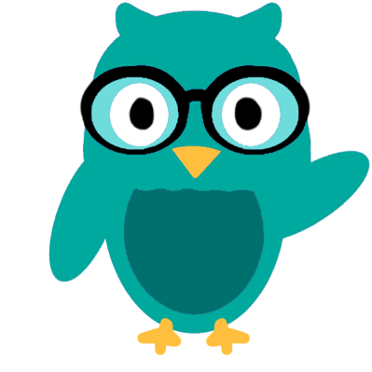
Do you want to help your toddler learn language?

Researchers in the LEARN Lab at Northwestern are studying a new mobile phone app that encourages children’s language development.
You can help by being part of a study.
Are you a parent with a child who…
- Is 18-30 months old
- Speaks English at home
- Is developing normally

What does the study involve?
- Download a free app on your phone
- Follow daily tips from the app for short language activities with your child
- Complete online questions about your child’s vocabulary
- Participate in two video calls where we will ask questions about your child’s development and record them while they talk

What do I receive?
- Families receive up to $95 in Visa or Target gift cards for participating.
- Or, you and your child may be invited to come visit us in person at our Chicago or Evanston locations to complete language activities. For completing these visits, you will receive up to $250 in Visa or Target gift cards.

How do I learn more?
Please email LEARNLab@northwestern.edu, call 847-868-2255,
or visit http://learnlab.northwestern.edu.

This research is being conducted by lead researcher Elizabeth Norton and the LEARN Lab at Northwestern University. This study was reviewed by the Northwestern University IRB (STU# 00205376).

